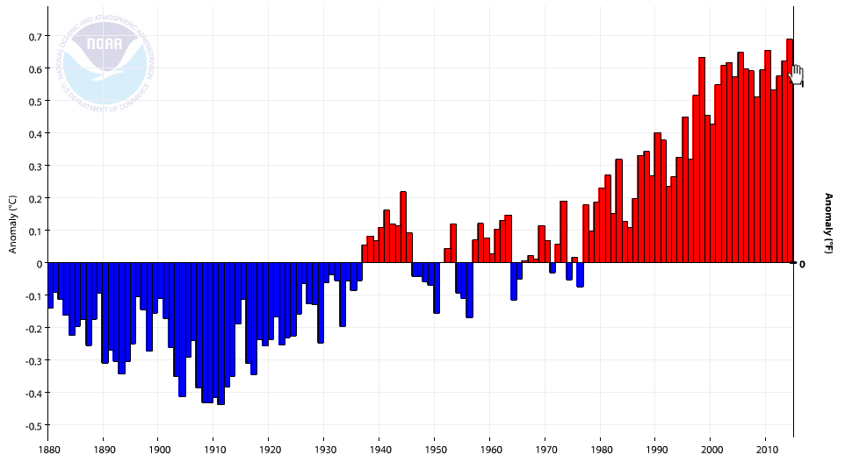

**Global land and ocean temperature anomalies relative to 20th Century avg.**

Source: NOAA National Climatic Data Center

Link: http://www.ncdc.noaa.gov/cag/time-series/global/globe/land_ocean/ytd/12/1880-2014